The areas that regulations do and do not apply

The specific areas this guidance does apply to are:

- breakfast clubs
- tuckshops
- community cafés serving children and young people during the school day
- before/after school clubs
- on a day to day basis in the classroom
- Any small group interventions where the focus is not on teaching food preparation and cookery skills

There are some circumstances in which the Regulations do not apply, however, when deciding to apply these exemptions, consideration should be given to the ethos of Gracemount Primary being a health promoting school. These circumstances are:

- Food or drink brought on to the premises by parents/carers e.g. packed lunch.
- Food and drink provided for people who are not pupils e.g. staff
- Food used in teaching food preparation and cookery skills so long as the food prepared is not part of a school meal
- Food or drink provided as part of a medically recommended diet for any pupil
- Food or drink as part of a social, cultural, or recreational activity e.g. school disco, sports day, PTA events and bake sales
- Food and drink brought into school by parents/pupils to celebrate birthdays or other milestones

Gracemount Primary School
Promoting Healthy Eating in School

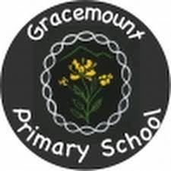

Developed in June 2021 from The Scottish Government’s ‘Nutritional Requirements for Food and Drink in Schools Regulations 2020’ and ‘Healthy Eating in Schools: guidance 2020’
Introduction
Gracemount Primary is a health promoting school which means it is always vital for Healthy Eating to be promoted in school. Our Healthy Eating policy has been developed from regulations created by the Scottish Government in relation to food and drink in schools that school and catering staff must adhere to.
It is essential we ensure that children experience a healthy and balanced diet in school as so many of Scotland’s children and young people fall short of national dietary recommendations and many are consuming inadequate amounts of fruit and vegetables and eating too much saturated fat, salt and sugar. Children must receive the right balance of food and nutrients in school to develop and grow. A good diet is about getting the balance correct. This is illustrated in the Eatwell Plate:

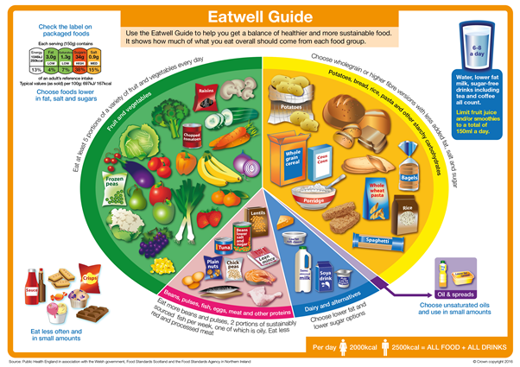

The ‘Gracie Way’ of providing food/drink for our learners
Here is a quick overview of the key points outlined in our Healthy Eating Policy:
- Only water and milk will be consumed during learning time in the classroom.
- Only water or milk will be offered to children who are thirsty.
- If children forget their snack a healthy snack will be provided e.g. a piece of fruit.
- If a child often does not have snack the class teacher will address this with the child’s parents in the first instance.
- Any food provided by the school will adhere to the Scottish Government regulations which give clear guidance of what a child is/is not allowed to consume in a school day out with school dinners.
- Teachers may have discussions with children about the snacks/drinks they bring to school to continue to promote healthy eating in school.
- School staff may guide and inform parents about appropriate snacks/lunches for the school day.
- Gracemount is a nut free school.

Top Tips for Parents when providing food/drink for the school day

- Children only have 15 minutes to eat their snack so bear this in mind when providing your child’s snack.
- Only provide the children with what you want them to eat not options.
- Use the eat well plate to plan a healthy and balanced diet for your child.

